- Purpose
  - The purpose of this document is to describe the procedure for assembling the scrub deck on a propane strip machine.
- Scope
  - This SOP applies to all equipment assembly team members. The process applies to the following machine ID’s:
E012327EQM0600BE1200 – Big Bertha XSM30 Propane Stripping Machine Pkg
E088398EQM0600BE1200 – Lil Bertha XSM24 Propane Stripping Machine Pkg
- Responsibilities
  - The operations manager/supervisor is responsible for enforcing this SOP.
- Materials
  - The proper materials needed for this process are listed on the machine work order.
  - Hand/Power Tools
- Definitions
  - BB – Big Bertha
LB – Lil Bertha
- Procedure
  - Begin with the brushes for the scrub deck. Place a fixed busing coupling (11342) onto the brush (11414 for BB / 86236 for LB) as shown. The hub on the coupling should face down and into the brush.

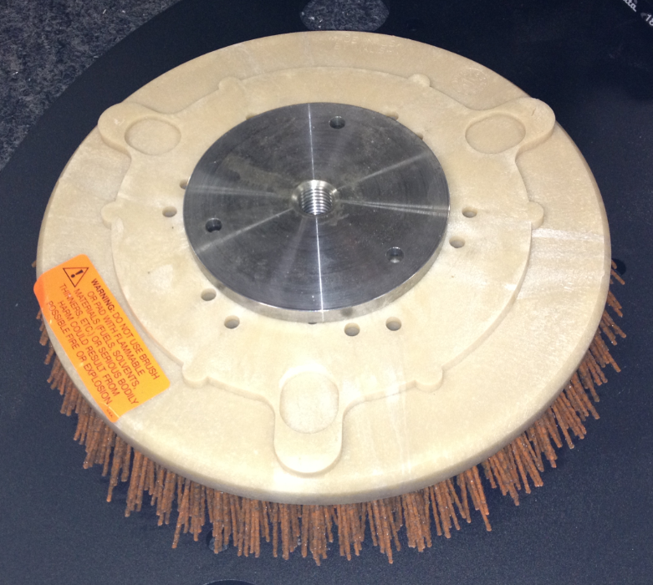

  - Fasten the coupling to the brush using 3 screws (83641 for BB / 87991 for LB) and 3 lock nuts (81063).

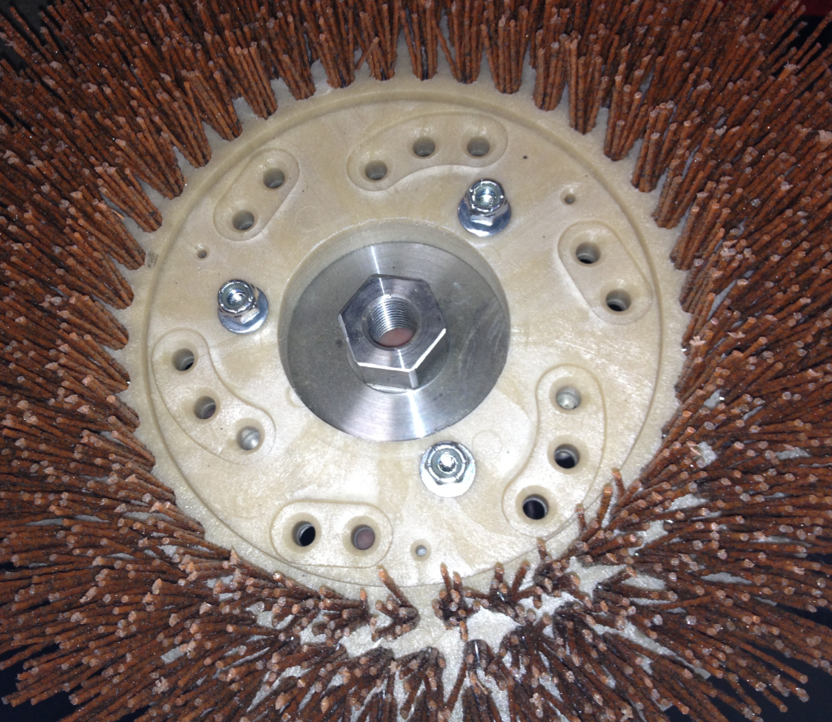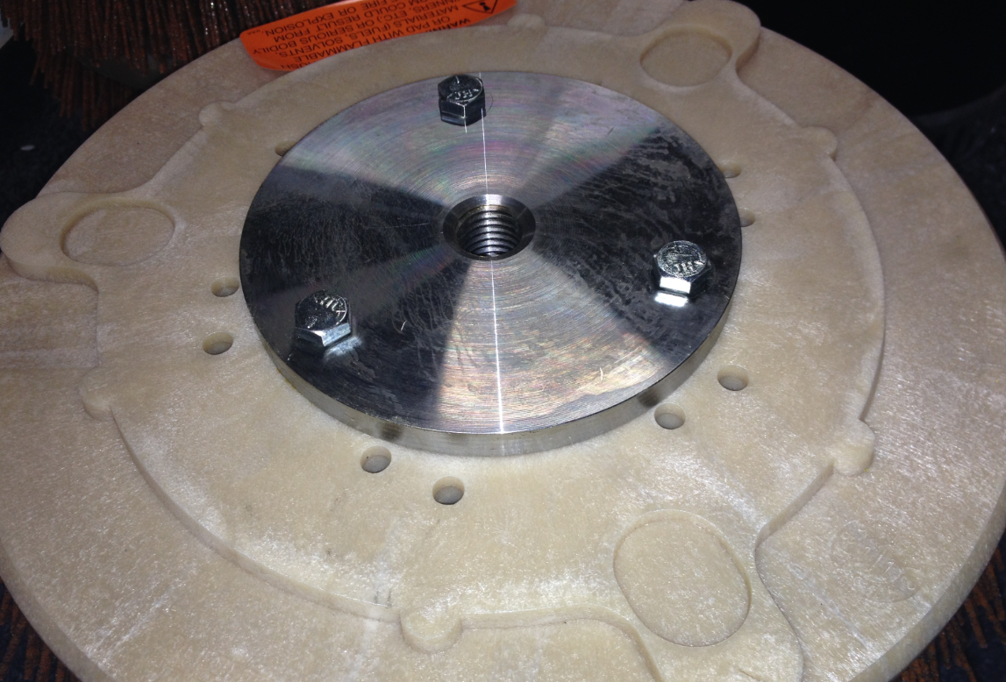
  - Repeat steps 1 and 2 two more times. Each machine needs 3 brushes.
  - Take a brush plate (11336 for BB / 86237 for LB) and bolt the main drive shaft assembly (11343) to it. The hub in the bearing housing fits into the cutout on the brush plate. The pulley is fastened using 4 bolts (10116), 4 lock washers (10117) and 4 washers (12447). The bolts thread right into the bearing housing.

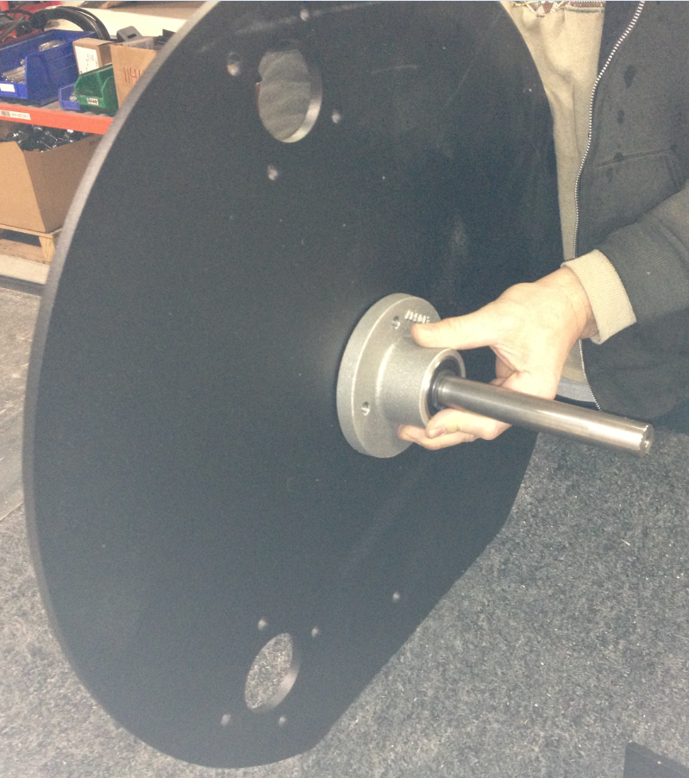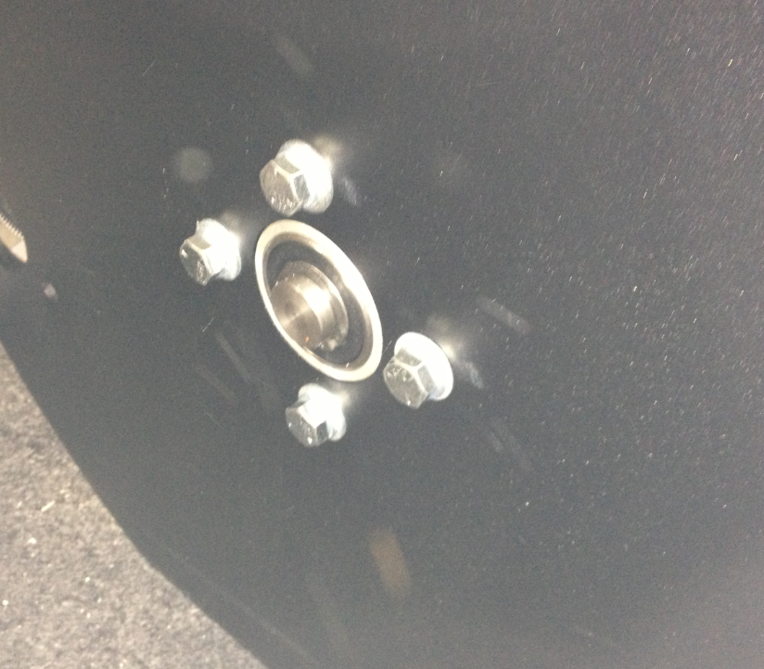
Brush Plate

  - Bolt 3 brush drive shaft assemblies (11344) to the brush plate in the orientation shown. Each of the 3 assemblies needs 4 bolts (10116),4 lock washers (10117) and 4 washers (12447).

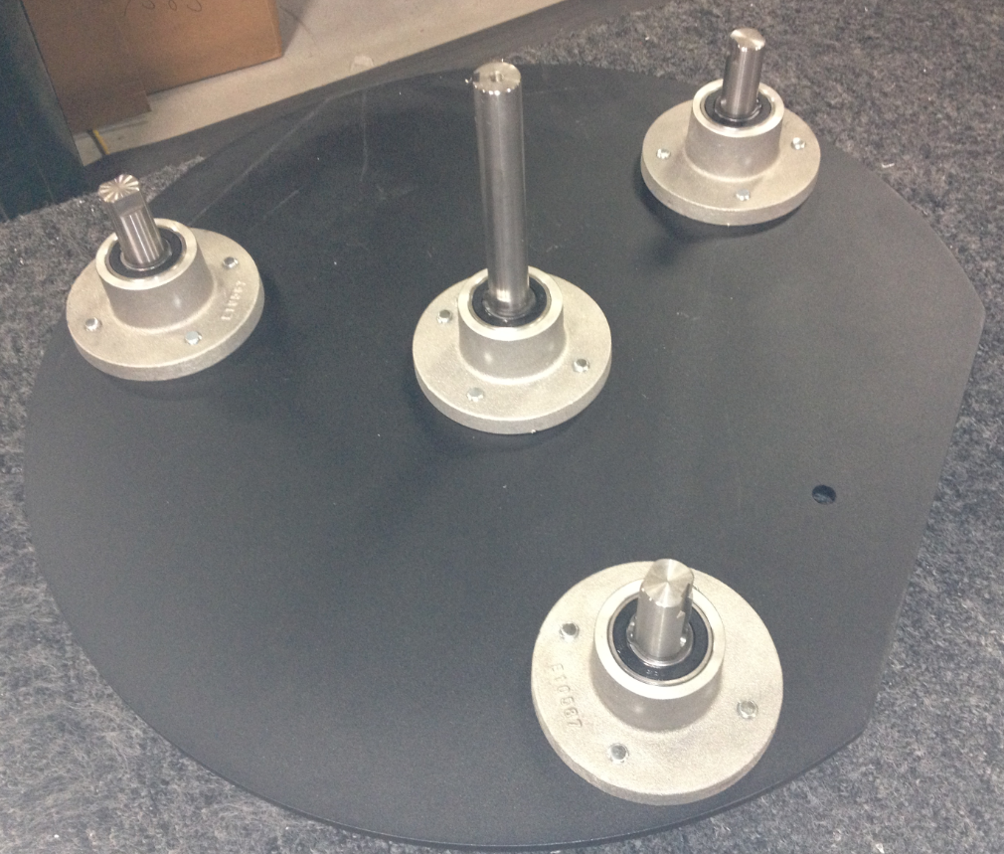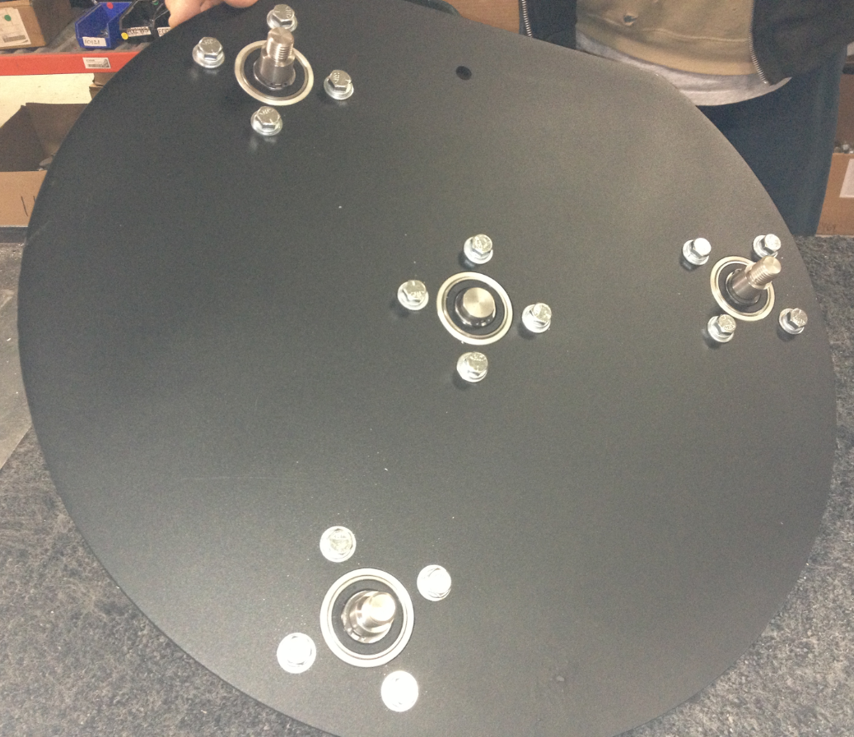

  - Attach the belt tensioner (10458) to the brush plate on the side shown. Attach it from the bottom using a bolt (12406), a lock washer (12409), and a flat washer (12407). Only thread the bolt in finger tight at this point. It will be tightened later when the belt tension is set.

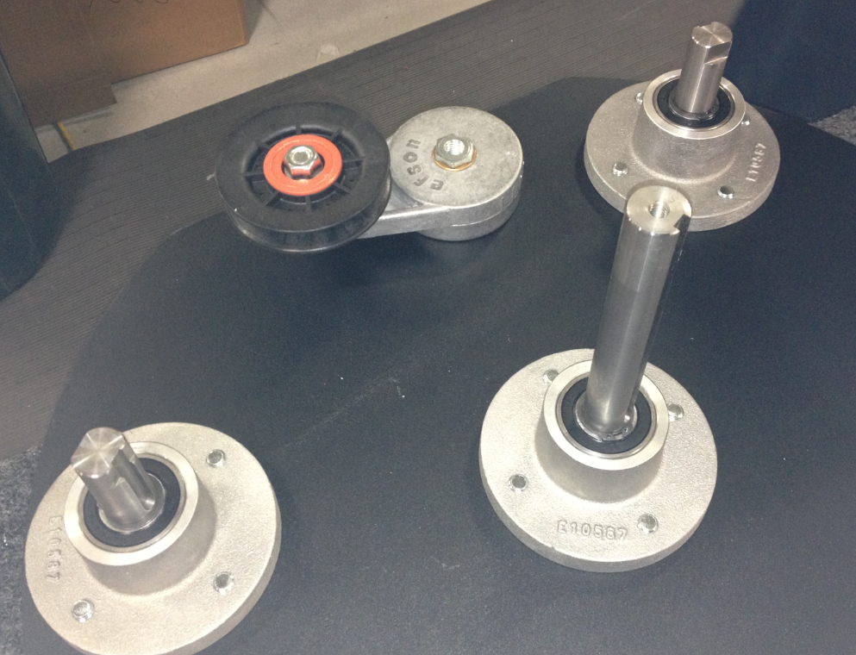

  - Install a key (12459) into the keyway on the center pulley. Tap it with a hammer to make sure it is installed flush. You want the key to be at the bottom of the slot as shown in the photo.

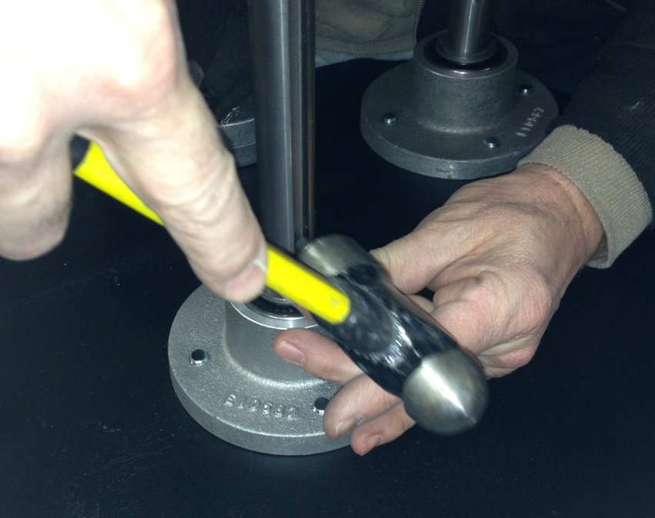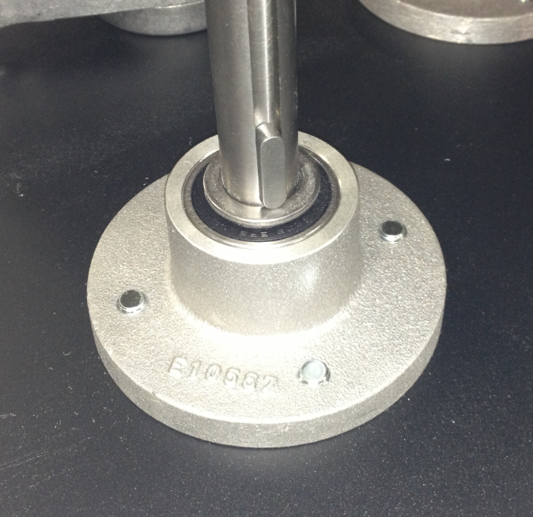

  - Take a pulley (11346) and place a bushing (12400) into the bore of it. The bore is tapered so that bushing will only fit in one direction. Line the holes up and hand start the bolt that holds them together. The bolts and washers are supplied with the bushing.

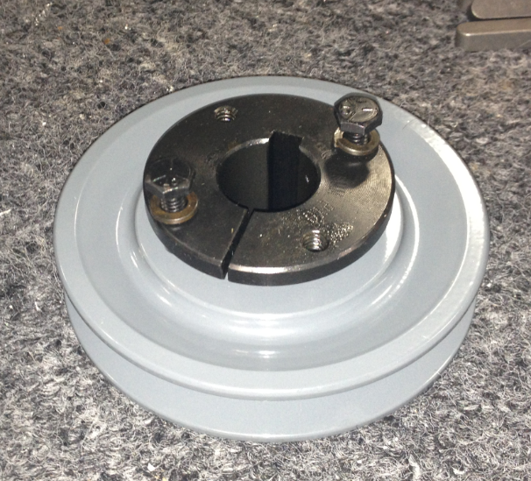
Bushing

  - Slide the pulley assembly onto the main drive shaft assembly. Line the key up and let it slide all the way down. Tighten the two screws by alternating back and forth little by little. This will make sure that the pulley stays level.

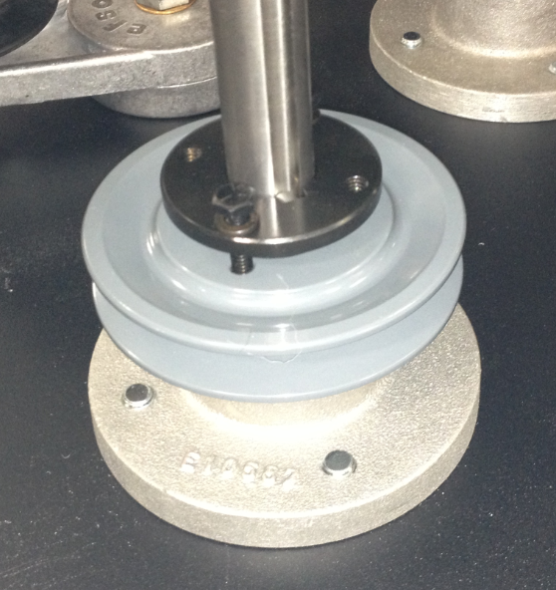

  - Take another pulley (11348) and place a bushing (12400) into the bore of it. The bore is tapered so that the bushing will only fit in one direction. Line the holes up and hand start the bolt that holds them together. The bolts and washers are supplied with the bushing.

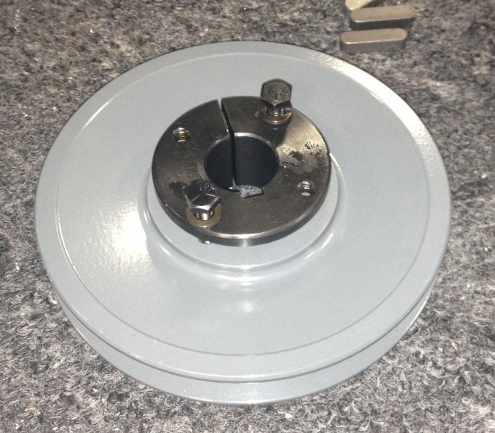
  - Install a key (12459) into the key way of one of the brush drive pulleys. Tap it with a hammer to make sure it is installed flush. You want the key to be at the bottom of the slot as shown in the photo.

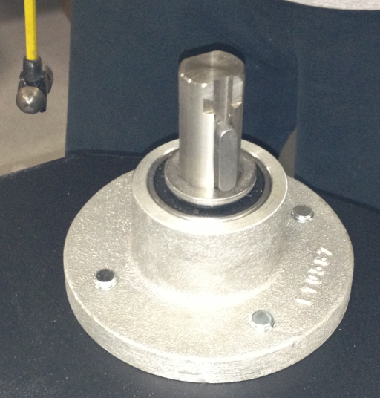

  - Slide the pulley assembly onto the brush drive shaft assembly. Line the key up and let it slide all the way down. Tighten the two screws by alternating back and forth little by little. This will make sure that the pulley stays level.

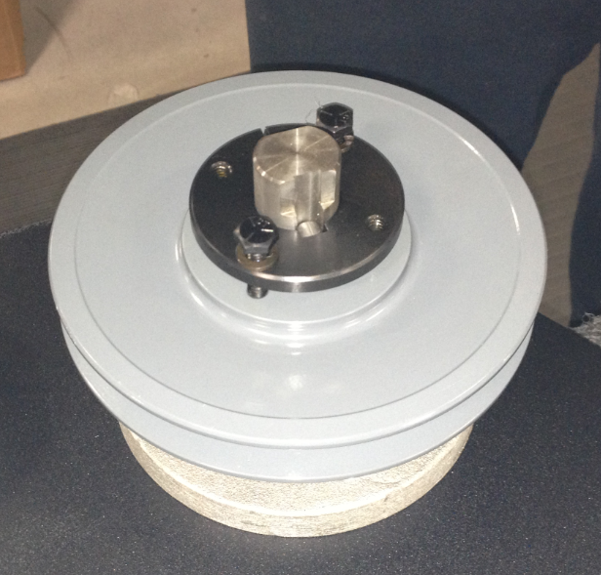

  - Repeat steps 10-12 for the other 2 brush drive pulleys.

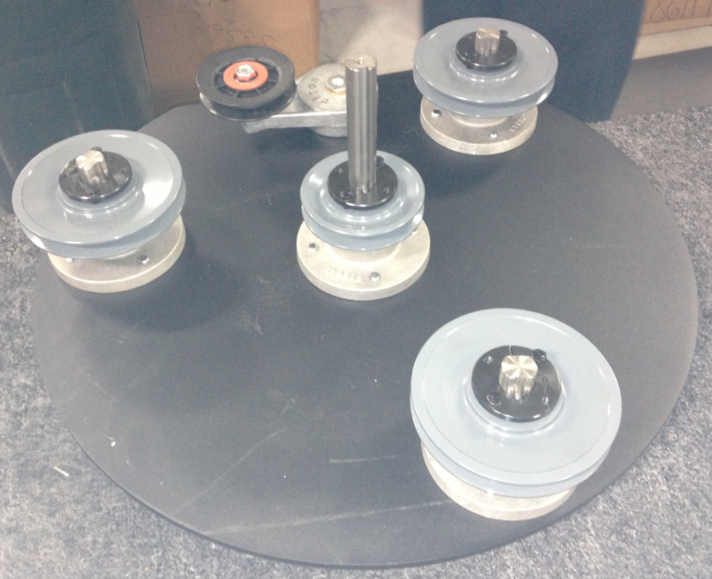
  - Take a belt (11349 for BB / 86239 for LB) and wrap in around the pulleys in the sequence shown in the photo. Note where the belt tensioner is.

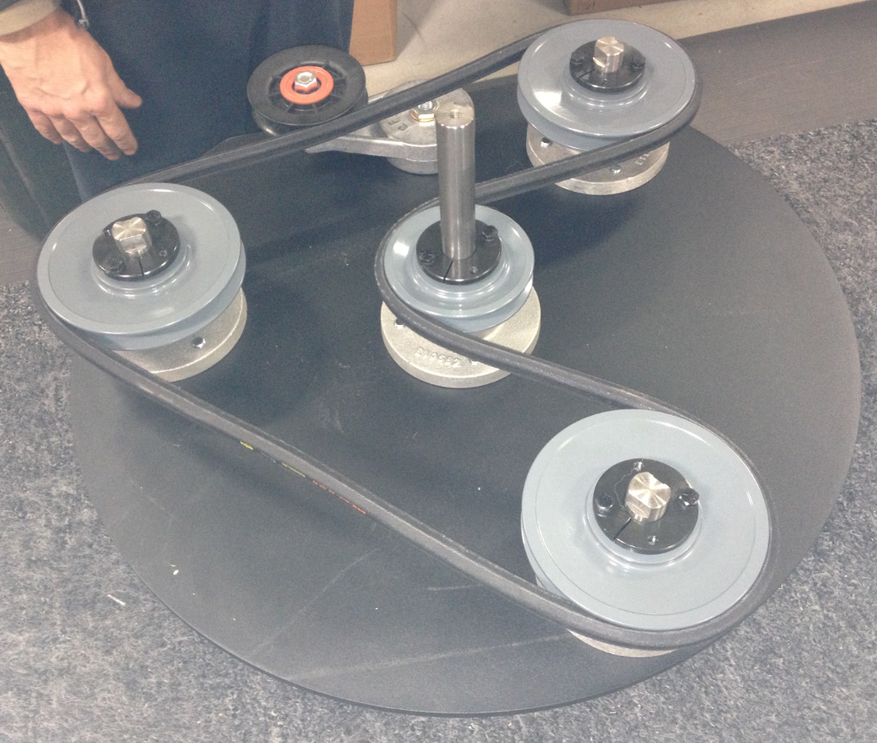

  - Use a large ¾” wrench to turn the tensioner pulley until the desired belt tension is reached. Tighten the bolt on the bottom to hold its location.

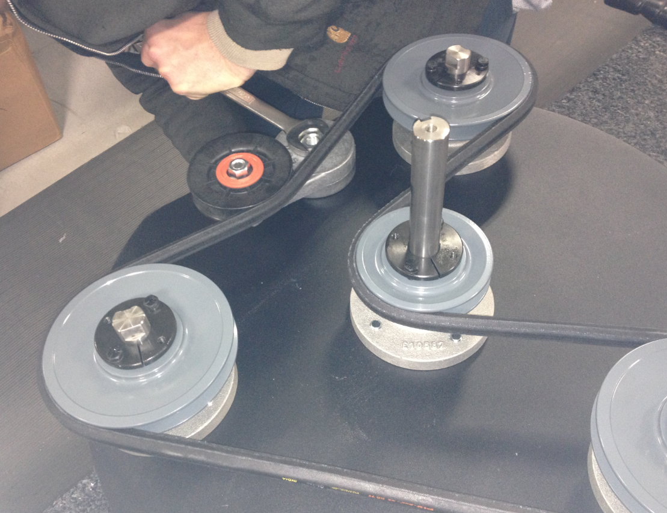

  - Flip the brush plate over and thread on the 3 brushes that were assembled earlier. These have left handed threads.

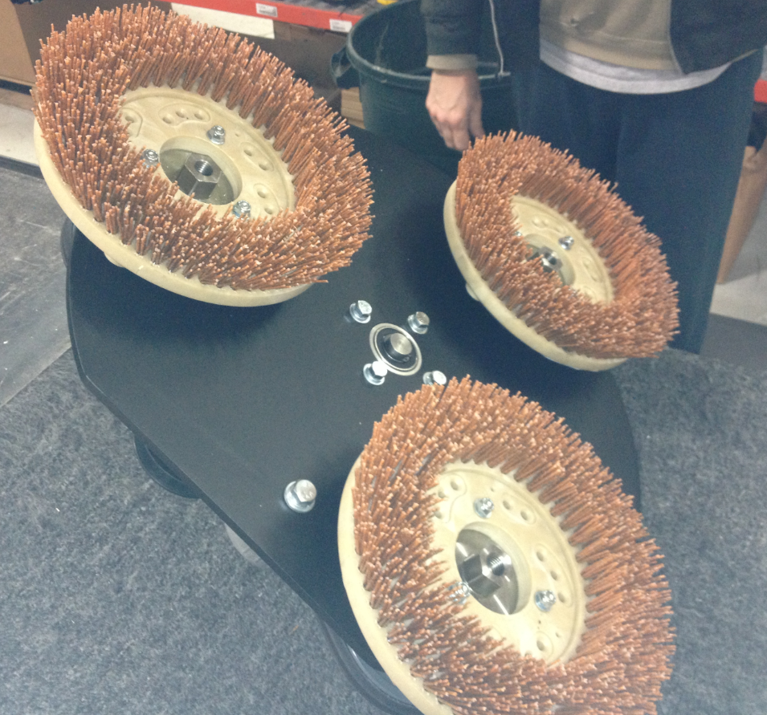

  - Flip the brush plate back over so that it is sitting on the brushes.
  - Take a pivot bracket (89828) and bolt 2 bearing assemblies (11347) and a spacer (89818) together as shown. It is very important to make sure that the grease zerks from the bearing point in the same direction. Fasten the assembly together using 4 bolts (89819), 8 flat washers (12447), and 4 lock nuts (11418). Do not tighten the bolts at this time. Note which side of the assembly the bolt heads are on.

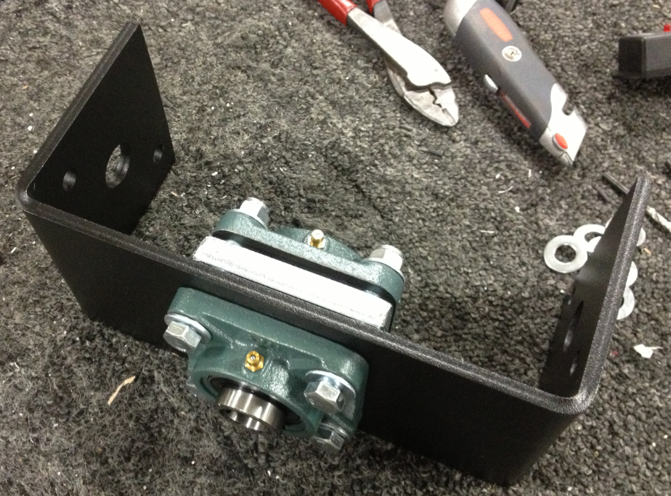
Zerks
  - Slide the bracket onto the main drive shaft as shown. Use a tape measure to verify that the assembly is level. Measure each end and tap a side up or down if needed. Note, the width of the bracket must be 10 ½” or less to ensure it fits in the deck.

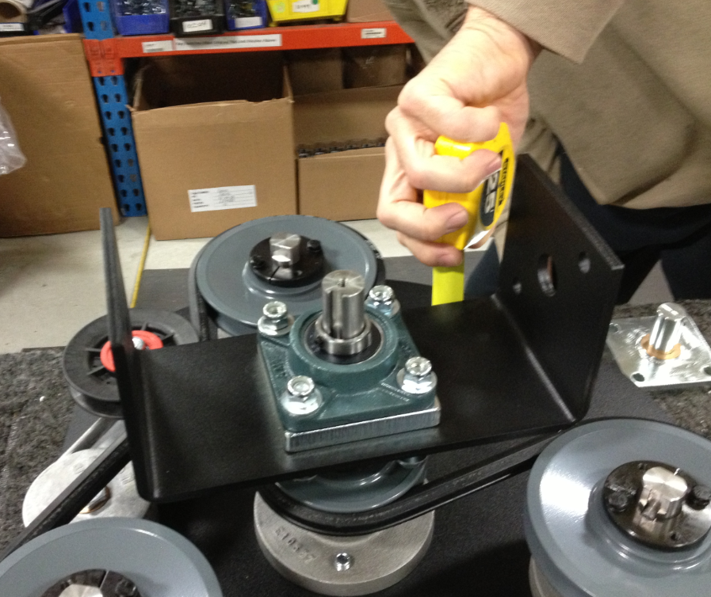
10.5”

  - Tighten the 4 bolts and nuts on the bearings with a 5/8” socket and wrench.

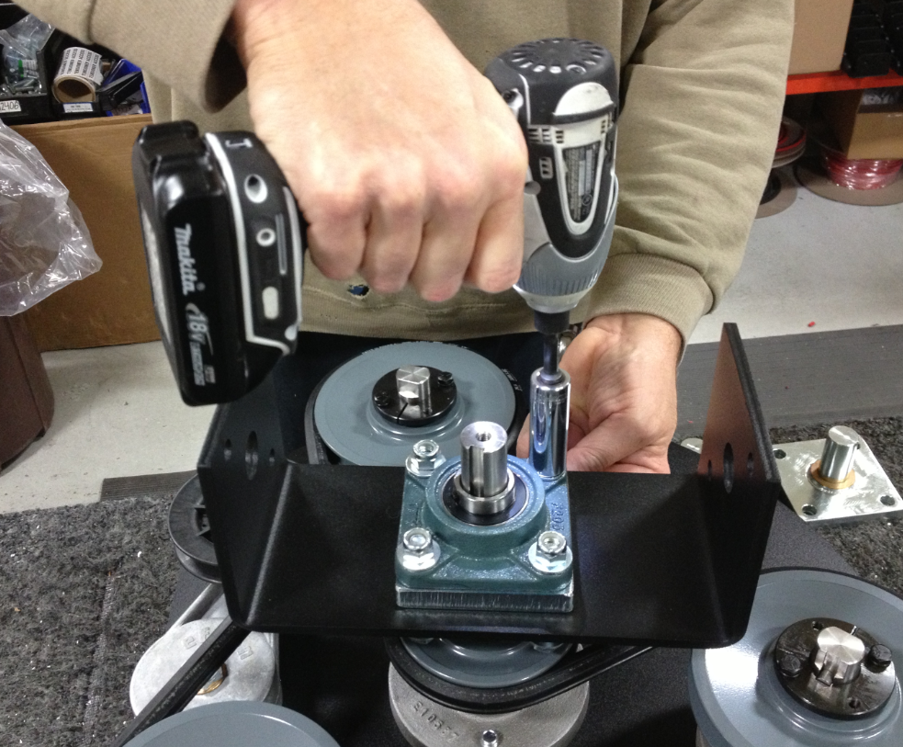

  - Tighten the set screws on the top and bottom bearing. Make sure that the screws do not line up with the keyways before tightening.

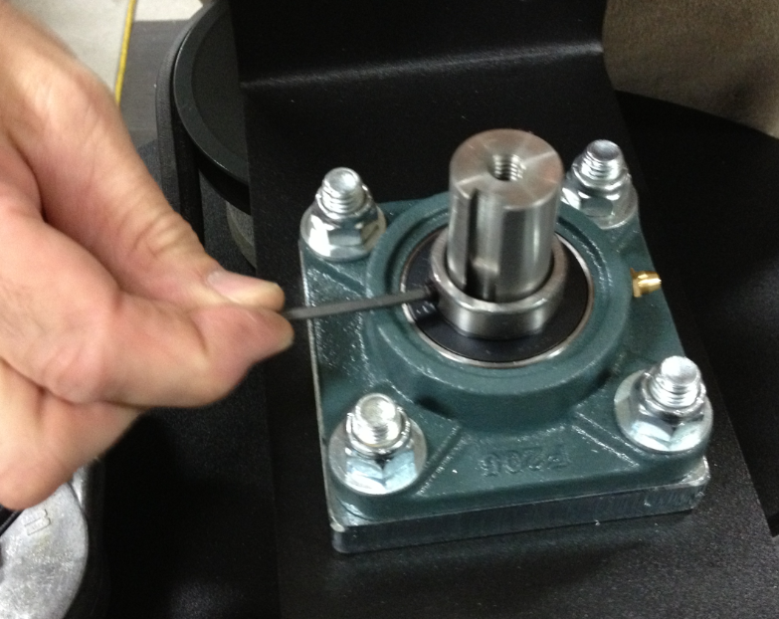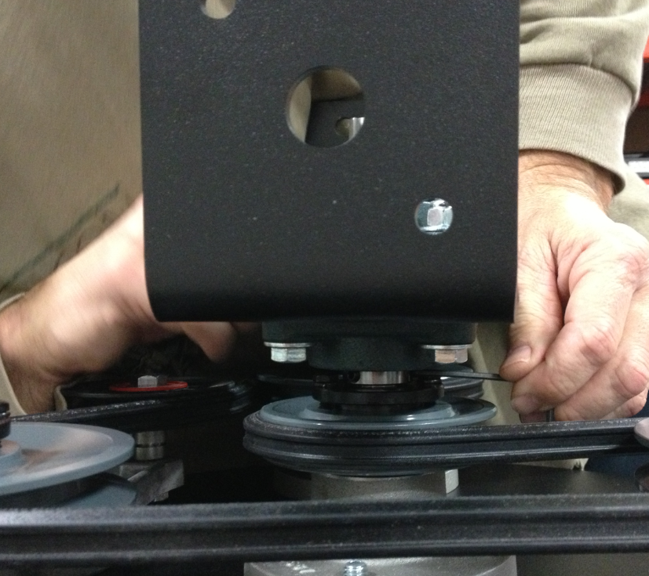

  - Use 2 bolts (86234), 4 flat washers (12447), and 2 lock nuts (11418) to attach a bearing block (89816) to the bracket as shown. Do not tighten the bolts yet. Note the orientation of the grease zerk relative to the zerks on the center bearings.

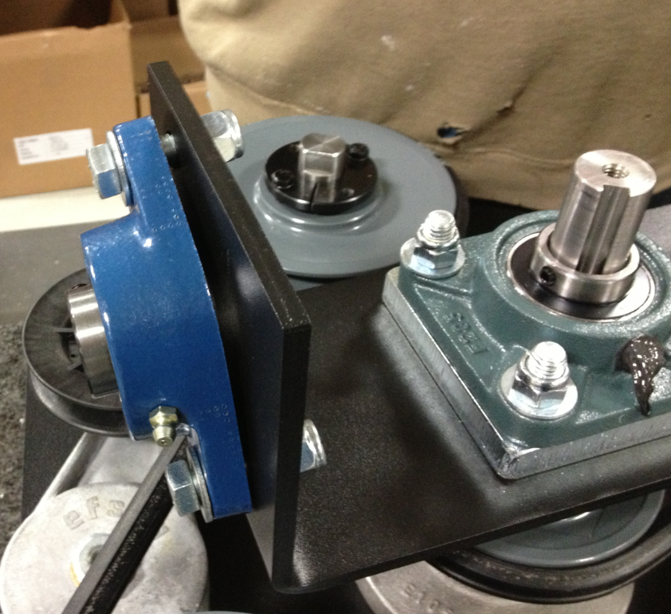
Zerk Orientation

  - Repeat on the opposite side. The zerk on that bearing should point the opposite way of the first.

  - Slide a pivot block (89782) into the bearing as shown. Repeat on the opposite side. Ensure the pivot blocks are completely inserted.

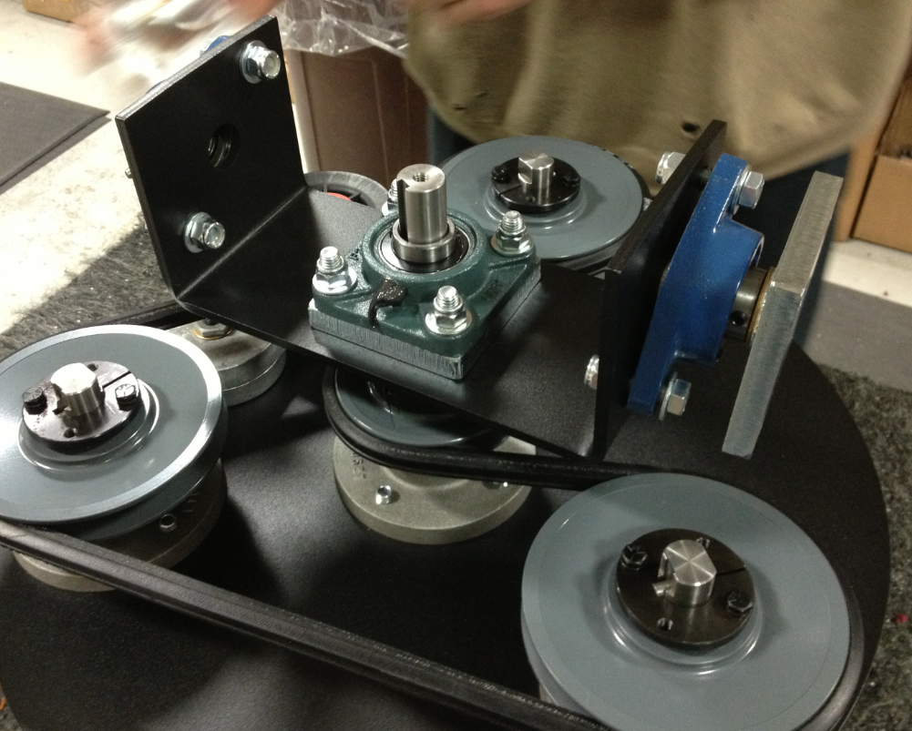

  - Tighten the bolts up that hold the bearings in place.

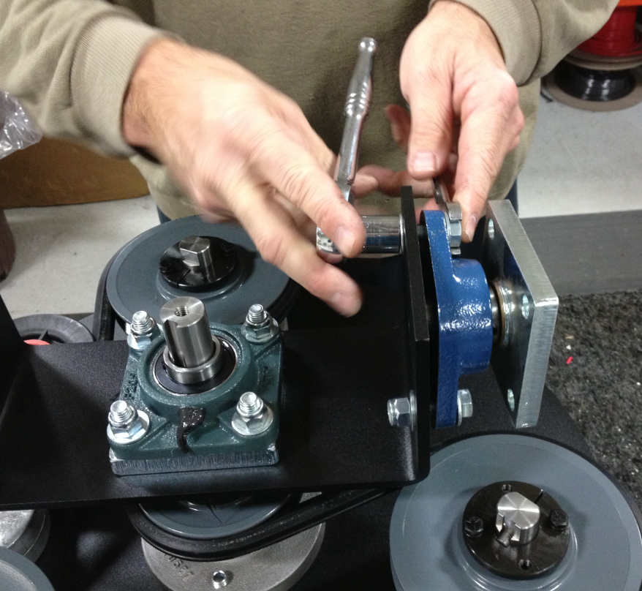

  - Tighten up the set screw on each of the bearing blocks.

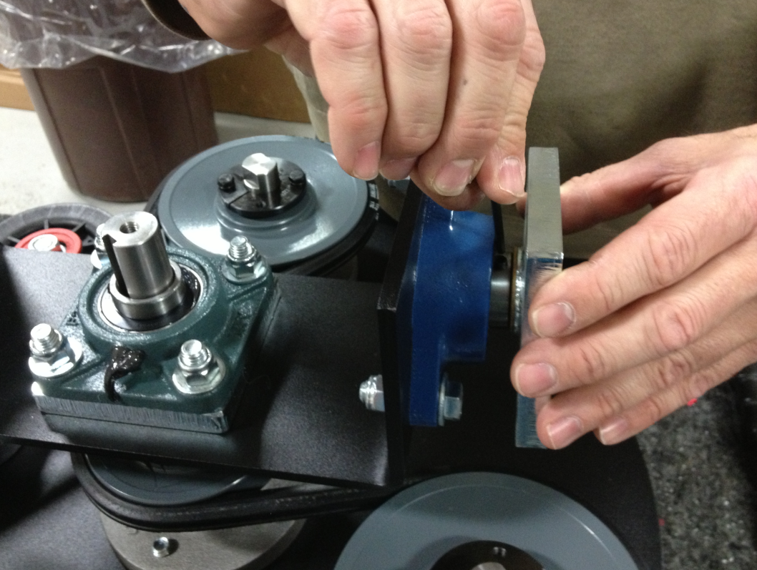

  - Put a couple pumps of grease into each of the bearings.
  - Take a pulley (11350) and place a bushing (12400) into the bore of it. The bore is tapered so that the bushing will only fit in one direction. Line the holes up and hand start the bolt that holds them together. The bolts and washers are supplied with the bushing.

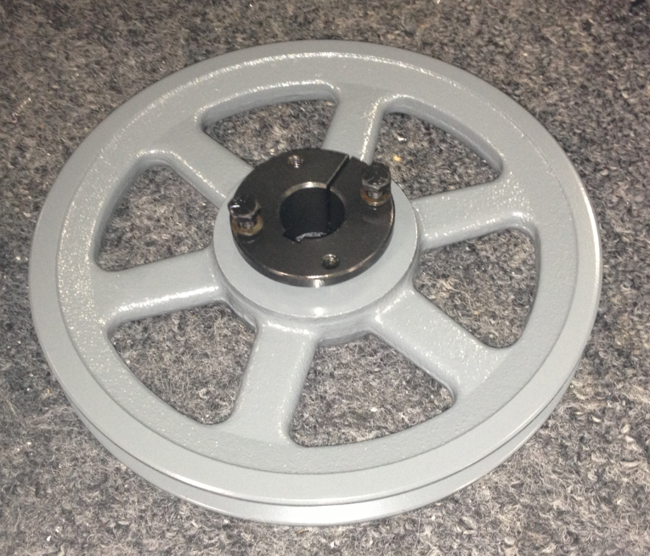

  - Slide the pulley assembly onto the main drive shaft assembly. Line the key up and let it slide all the way down. The top of the bushing should line up with the top of the shaft.

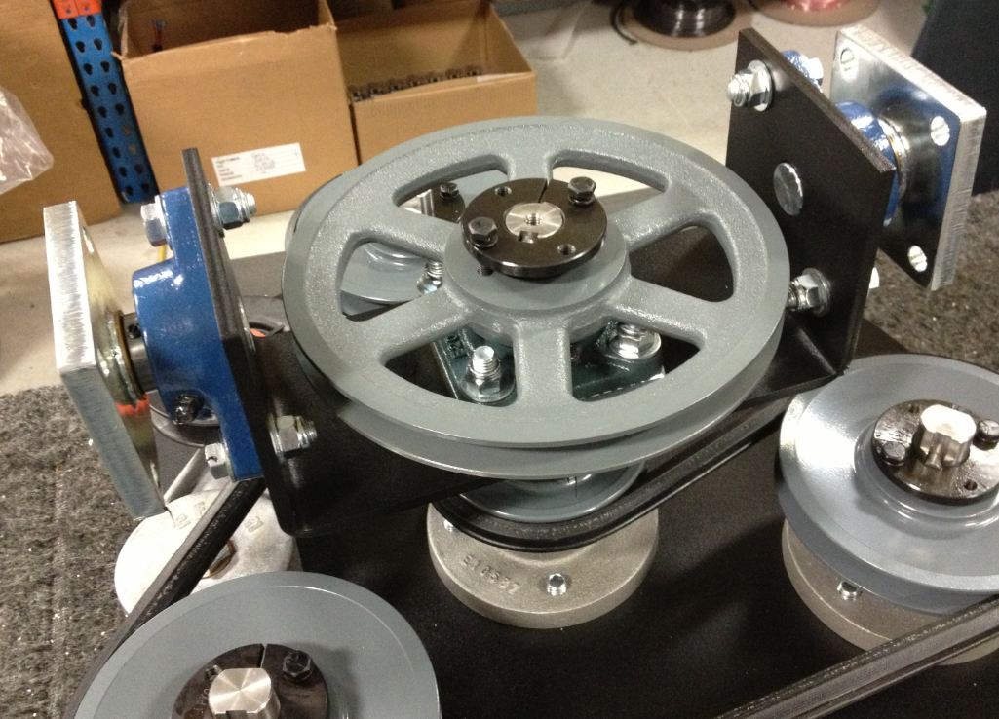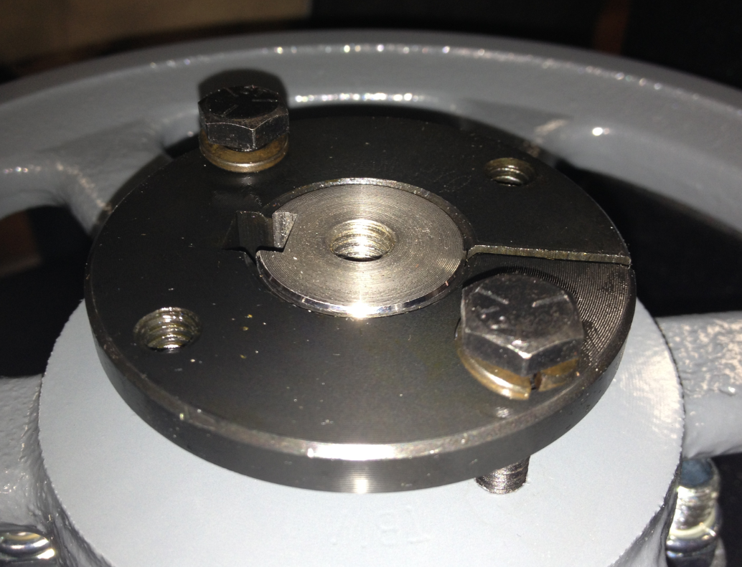
These surfaces should be level

  - Install a key (12459) into the key way. Verify that the key does not sit above the end of the drive shaft.

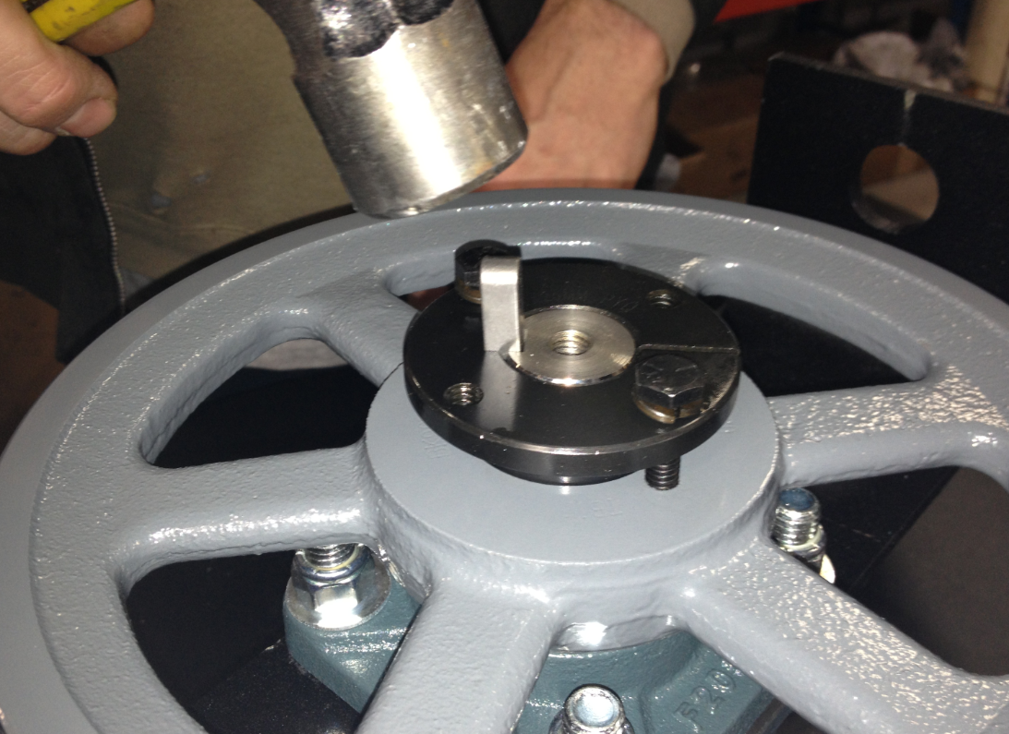

  - Tighten the two screws on the bushing by alternating back and forth little by little. This will make sure that the pulley stays level.

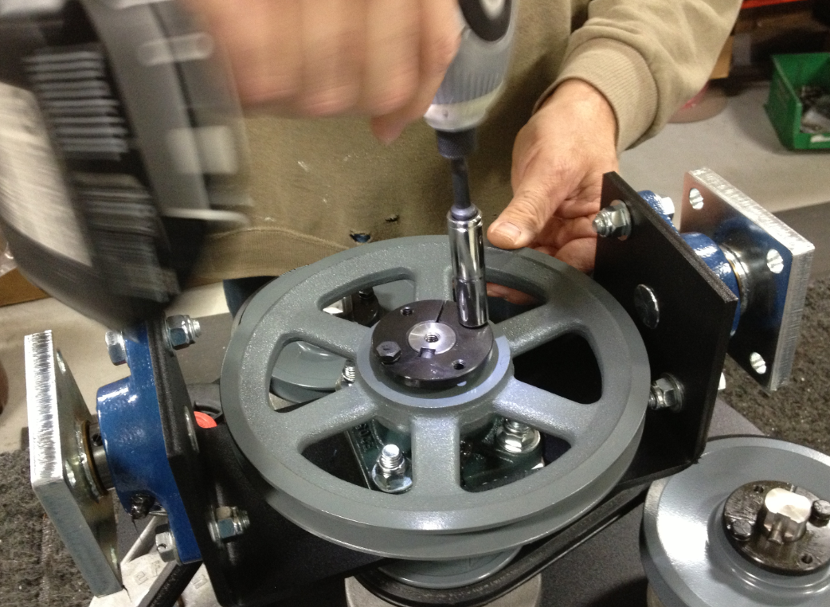

  - Use a bolt (81072), a lock washer (81067), a flat washer (12444), and a large flat washer (11501) to hold the entire assembly together. Put some blue Loctite onto the threads before installation. Make sure that the large washer covers the key that was installed to prevent it from falling out.

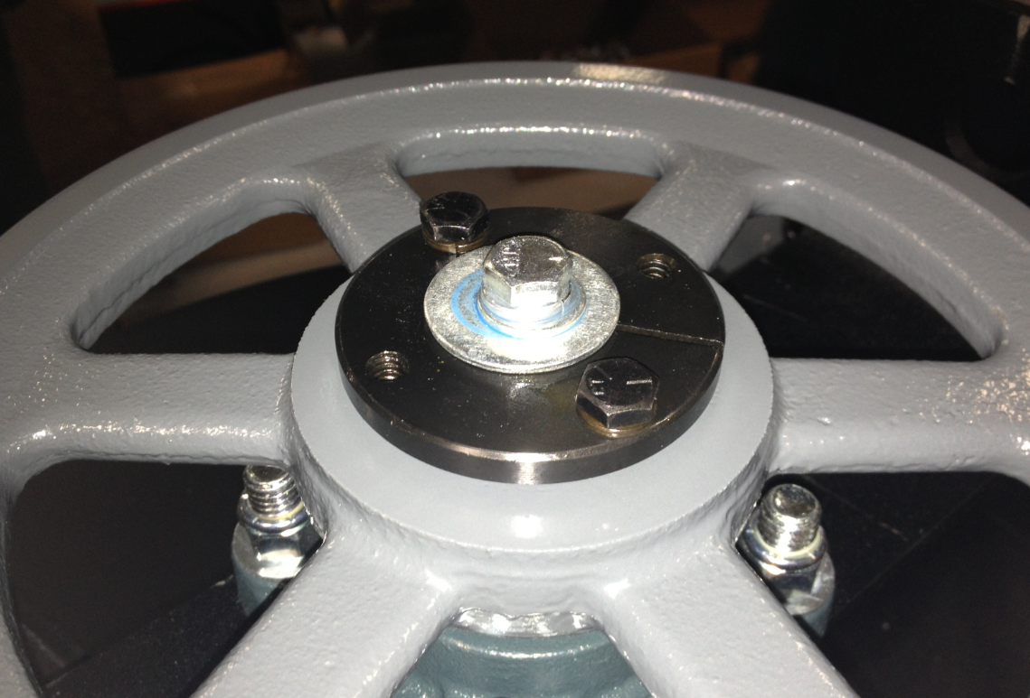

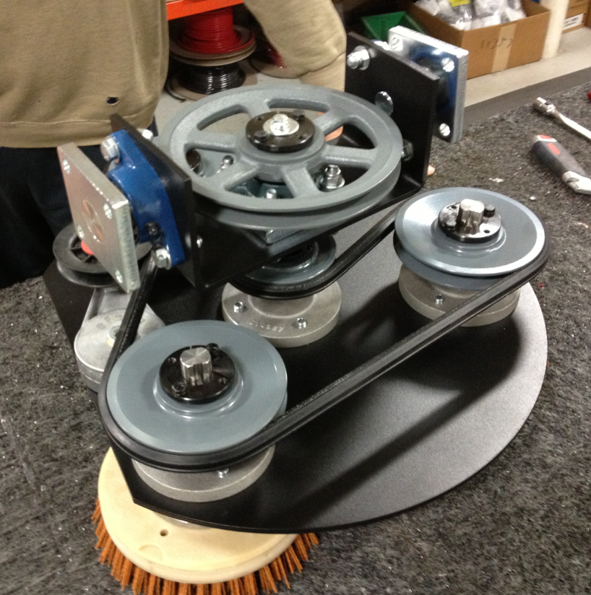

- References (optional section as needed)

- Training Guide

Functional Training Groups Requiring Training

- SOP Change Control

Date of Change | Reason for Change
11/25/2013 | This is the first version of the S.O.P. hence there are no revisions to this document.
1/18/2018 | Added Responsibilities Section
5/30/2024 | Updated part numbers and removed steps in process
3/17/2025 | Removed work center notes

Approvals

Submitter/Author Approval:__________________________________ Date:______________________

Management Approval:______________________________________ Date:______________________

QAU Approval:_____________________________________________ Date:______________________

